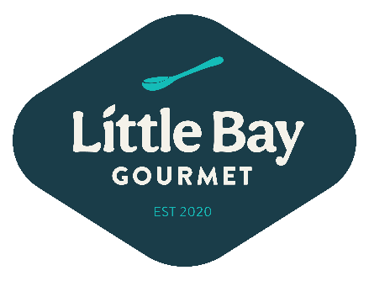
LUNCH CATERING MENU 2026

SANDWICHES
#1 Turkey, Avocado, Lettuce, Tomato, White Cheddar, Basil Aioli, Wheat Bread

Roast Beef, Dill Havarti, Tomato, Pickled Red Onion, Lettuce, Deli Sauce, Marble Rye

Ham, Brie Cheese, Apple, Dried Cherry Aioli, White Bread

The Veggie-Shaved Carrot, Cucumber, Summer Squash, Peppadew Pepper, Preserved Lemon Hummus, Micro Greens, Sourdough

The Italian- Salami, Mortadella, Capocollo, Giardiniera, Provolone, Lettuce, Italian Dressing, Mab’s Mustard, Ciabatta

Chicken Salad- Dried Cherry, Pecan, Apple with Lettuce, Sourdough

Ham, Swiss Cheese, Banana Pepper, Lettuce, Yellow Mustard, White Bread

Turkey, Pepperjack, Bacon, Honey Mustard, Lettuce, Wheat Bread

Flat Iron Tuna Salad- Green Olives, Celery, Lettuce, Marble Rye

Mab’s Curried Chicken Salad- Grapes, Celery, Lettuce, Tortilla Wrap

Corned Beef, Sauerkraut, Pickle Relish, Stone Ground Mustard, Lettuce, Caraway Bread

Avocado Egg Salad, Sundried Tomato Pesto, Lettuce, Wheat Bread

Wagyu Pastrami, Pickles, Lettuce, Dijonnaise, Marble Rye ($2 upcharge)

MINI SANDWICHES $40/dozen
HALF SANDWICHES $75/dozen

BOXED LUNCH
Full Sandwich, chips, side* $17.50
Half Sandwich, chips, side* $12.50
*choice of sides
Add a mini cookie $1
*SIDES $11.99/lb
Caprese Pasta Salad- Cherry Tomato, Fresh Mozzarella, Basil Dressing

Greek Pasta Salad- Cucumber, Tomato, Red Onion, Olives, Feta, Greek Vinaigrette

Classic Mustard Potato Salad- Dill, Celery, Red Onion

Bacon Ranch Potato Salad- Cheddar Cheese, Green Onion

Corn and Farro Salad- Basil, Parsley, Pickled Red Onion, Goat Cheese

Watermelon Feta Salad- Mint, Radish, Fustini’s Jalapeno Lime Vinaigrette
*SIDES $9.99/lb
Fresh Fruit and Berries

Creamy Coleslaw

Asian Slaw- peas, radish, red bell pepper, Wasabi Vinaigrette
SALADS $11.99/pound
‘Greekish’- Castelvetrano Olive, Cucumber, Tomato, Feta, Marinated Beets, Mix Greens, Greek Vinaigrette

Cobb – Chicken, Bacon, Tomato, Hard Boiled Egg, Cucumber, Blue Cheese, Romaine, Ranch

Parkside – Tomato, Cucumber, Carrot, Greens, Croutons, Mix Greens, Balsamic Vinaigrette

Summer Strawberry Salad- Almonds, Goat Cheese, Mix Greens, Poppyseed Vinaigrette

Great Lakes Potato Chips
OG, Sea Salt & Vinegar, Michigan Cherry BBQ, Parmesan Ranch
Individual $2
Family Size $12

Hot Bar Meals
Loaded Baked Potato Bar- Idaho, Pulled Pork, BBQ, Sour Cream, Cheddar, Green Onion, Bacon $16/person
Chicken Shawarma Bar- Moroccan Spiced Chicken, Tomato Olive Feta Salad, Sumac Cauliflower Golden Raisin Quinoa, Rice stuffed Grape Leave, Lettuces, Naan, Hummus, Tzatziki $18/person

SWEETS
LARGE COOKIES $24/dozen
Rotating Chef Selection
MINI COOKIES $12/dozen
Rotating Chef Selection
GLUTEN FREE CHOCOLATE WALNUT BROWNIES $24/DZ

BEVERAGE
Bottle water $1.25 each
Assorted Faygo cans $1.60 each
OHY (Hydrogen Water) cans $1.75 each

